YouTube link: <https://youtu.be/8k-ai4Jg0zE>

HTML

1 – Creates a nav bar with a button next to it.

2-Creates a table with my contact information.

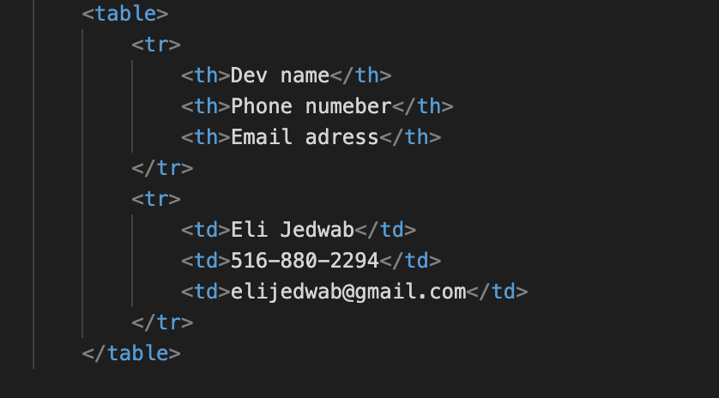

3- Creates logos with numbers and their titles.

4- Makes a container with pictures inside.

CSS

5 – Creates an animation which makes something bigger and the opacity to 0.

6 – Makes item grey and bigger when the cursor is hovering over it.

7 – Displays items in a column and centers them. Adds a margin and makes the contents white.

8 – Makes the h3 content white and positioned a little up from the bottom. Also adds a shadow to the text.

JavaScript

9 – Makes a button toggle between being active and not.

10 – Tells your computer where on the button you clicked and then plays the circle animation there.

